Exposures to Allergenic Pollen for General U.S. Population

**Abstract**

Allergenic pollen is the main factor causing Allergic Airway Disease (AAD), which is affecting 5%-30% population in the industrialized countries. Furthermore, allergenic pollen has been reported to act synergistically with common air pollutant, such as ozone and particular matter, to exacerbate the situation of allergy suffers. Studies on allergenic pollen exposure will help to provide useful information for scientific community to relieve the allergy suffers.

In the current study, a probabilistic exposure modeling system has been developed using Monte Carlo methods to simulate the exposures to allergenic pollen for general population in the United States. The simulation was conducted by sampling randomly from distributions of outdoor and indoor allergenic pollen concentration, and distributions of activity data from general US population. These activity data include indoor and outdoor activity time, inhalation rate, exposed skin area, hand-to-mouth touch frequency, etc. Distributions of allergenic pollen concentration from representative trees, weeds and grass in nine climate zones were calculated based on observed pollen counts from the American Academy of Allergy Asthma and Immunology (AAAAI) monitoring stations. Demographic data of United States were used to generate the distributions of activity data according to age and gender in the corresponding climate zones.

The medians of daily total exposure intakes over United States were 88±317 pollen / day for birch, 263±1293 pollen / day for ragweed, 284±927 pollen / day for mugwort, 933±4065 pollen / day for grass and 822±3171 pollen / day for oak. Global sensitivity analysis based on Morris’ design was used to investigate sensitivity and interaction effect of the model parameters and inputs to the daily exposure intakes to allergenic pollen. Exposure estimates were sensitive to parameters corresponding to pollen deposition, surface loading. The inhalation route contributes 140 and 157 times higher pollen exposure levels for residents than dermal contact and unintentional ingestion route, respectively.

# Background Information

Airborne allergenic pollen was found that by acting synergistically with some air pollutants like ozone, will cause allergic airway disease (AAD) and the related health cost will increase (Lamb, Ratner et al. 2006, Singh, Axelrod et al. 2010). It is reported that over one third of the US population are suffering allergic symptom and diseases in different levels, including rhinitis, hay fever, asthma, and atopic dermatitis (Bielory, Lyons et al. 2012). These allergic diseases can be potentially triggered and aggravated by allergenic pollen, such as ragweed, birch, grass, mugwort and oak, which we will discuss in the article (Shea, Truckner et al. 2008).

## Pollen and allergy

Asthma, rhinitis, and conjunctivitis are often considered as the typical clinical pictures of allergy to pollen, and they often occur in the same patient simultaneously during the pollen season (Sofiev, Belmonte et al. 2013). Among these three symptoms, asthma is often considered as the most common one. It is a chronic inflammatory disease of the airways characterized by recurrent episodes of wheezing, breathlessness, chest tightness and coughing (Bateman, Hurd et al. 2008). Exposure to allergens represents as a key factor among environmental determinants of asthma, rhinitis, and conjunctivitis (Eder, Ege et al. 2006). IgE which is a class of antibody in human body plays an essential role in hypersensitivity,(Gould, Sutton et al. 2003) causing various allergic diseases. Allergic rhinitis is defined as a symptomatic disorder of the nose induced by an IgE-mediated inflammation after allergen exposure of the membranes lining the nose. Symptoms of rhinitis include rhinorrhea, nasal obstruction, nasal itching and sneezing which are reversible spontaneously or (Brożek, Bousquet et al. 2010) under treatment. Pathophysiological and clinical studies have strongly suggested a relationship between rhinitis and asthma. However, epidemiology provides the most convincing data, showing that the prevalence of asthma in patients with rhinitis varies from 10 to 40 % depending on the study (Sofiev, Belmonte et al. 2013). Moreover, allergic rhinitis is correlated to, and constitutes a risk factor for, the occurrence of asthma. Taken together, these epidemiology data have led to the concept that upper and lower airways may be considered as a unique entity influenced by a common, evolving inflammatory process (Passalacqua and Durham 2007). Conjunctivitis is also commonly associated to pollen-induced rhinitis.

Sensitization occurs at the site of allergen exposure, such as airways, but can also occur through the dermal tract. However, not everybody who is exposed will become sensitized and have allergies. Aside from the individual exposure conditions, there is a high variability in the individual responsiveness to a given allergen dose.

The most important allergen carriers in the outdoor air as well as in the indoor air are pollen – with a diameter between 15 and 60 µm – from anemophilic plants such as trees, grasses and weeds. In this thesis, we discuss five different species, which are ragweed (Ambrosia), mugwort (Artemisia), birch (Betula), grass (Gramineae) and oak (Quercus). However, whole pollen grains are too large to penetrate the small airways. Since pollen is able to evoke IgE-mediated allergic reactions within seconds after contact with the mucosa, pollen allergens must be extremely water soluble and readily available. In fact allergen liberation from pollen grains can occur on the mucosal surface of the upper respiratory tract after exposure to pollen (Behrendt and Becker 2001). Symptoms can be explained by the interaction between the antigen and its corresponding IgE antibody and this phase is situated at the end of a cascade of events leading to allergy.

## Pollen Season

Different methods of observations and measurements, such as phenological events and pollen counts could be used to identify the same phenomenon, the flowering of plants. Similarly, both phenological and aerobiological data can be modeled in many aspects using a similar set of observation-based models. The first method is the regression model which could be used to predict phenological phases, start date and end date of the pollen season, and the peak value. The second one is the phenological model which would also predict the entry dates of phenological phases as well as the start, peak and end of the pollen season. Phenological models are sometimes classified into the class of process-based models (Chuine, Belmonte et al. 2000), the reason is that they are mainly based on assumptions rooted in experimental results on plant physiological responses to various environmental variables. In this thesis, pollen counts are used as the key data to calculate the length and start date of the flowering.

# Methods

## Data Collection

### Pollen Data Collection

Observed airborne pollen data were retrieved from the American Academy of Allergy Asthma and Immunology (AAAAI) monitoring stations during the period of 1994-2010 in the contiguous US (CONUS). The geographic locations of AAAAI pollen monitoring stations are displayed in Figure 5. The reported pollen data were classified only at the level of genus. Species under genus of Ambrosia, Artemisia, Betula, Gramineae or Quercus were not differentiated. The collected airborne pollen counts were used to generate the distributions of daily pollen concentrations in nine climate regions as shown in Figure 4.

### Population Data and Exposure Factors

The population data is from the United States census bureau. The demographic data contains the general population information (Census Bureau. U.S 2010), in which the state-level population is classified by age group and sex. We combined those data, using ArcGIS to generate the population data according to age and gender in 9 different climate regions to couple with the corresponding pollen data. Normalization method is used to scale the size of the population down to 5000 people in each climate region. The age and sex composition remains consistent in the normalization process.

The Exposure Factor data were obtained from USEPA’s Exposure Factors Handbook (U.S. Environmental Protection Agency 2010). These factors include the inhalation rate (Figure 7), dermal contact frequency, skin surface area (Figure 8), hand surface area, indoor and outdoor time (Table 5) and other exposure factor data in different age groups and sex. In each age group, ten different percentiles level (5th, 10th, 25th, 50th, 75th, 90th, and 95th) and mean values of exposure factors are used to generate the exposure scenario in the nine climate zones.

These exposure factor data are all in country-level. Inhalation rate distribution and other exposure factors are the same for different climate regions, although the temperature, day and night time and other environmental factors may surely affect values of those factors.

## Exposure Method Selection

Exposures to allergenic pollen can occur via inhalation and dermal contact (Sofiev, Belmonte et al. 2013), as well as unintentional ingestion (Cohen, Yunginger et al. 1979).

### Inhalation

Exposure intake can be quantified by multiplying the concentration of an agent and the exposed duration. Exposure can be instantaneous when the contact between an agent and a target occurs at a single point in time and space. The summation of instantaneous exposures over the exposure duration is called the time-integrated exposure. Equation shows the time-integrated exposure (Fogh and Andersson 2000).



where:

1. E = Time-integrated exposure (mass),
2. t2– t1 = Exposure duration (ED) (time),
3. C = Exposure concentration as a function of time (mass/volume).
4. I = Inhalation factors (volume/time).

Time-averaged exposure was obtained by dividing the integrated exposure by exposure duration.

In the current study, the daily concentrations from the AAAAI are sampled by day. An assumption was made that pollen concentrations are the same in the whole 24 hours of each day, neglecting the fluctuation of concentration in the time-scale of hour. Then the exposure (inhalation exposure) could be generated by multiplying daily concentration and inhalation rate, which are sampled from distributions.

Then we considered the indoor and outdoor exposures as in equation and .

Outdoor:



Indoor



1. Where E = Time-integrated exposure (pollen counts),
2. t2– t1 = Exposure duration (ED) (day),
3. C = Exposure concentration as a function of time (pollen/m2).
4. I = Inhalation factors (m2/day).
5. (dimensionless) and (m s-1)are ventilation rate and indoor deposition velocity, respectively.

### Dermal Exposure and Ingestion

Dermal exposure to volatile chemical compound has been studied (Hu, Zhang et al. 2011), however, the reports to the dermal exposure to pollen remains rare. We used dry deposition model to estimate the adherence of pollen on human skins.

The dry deposition model assumed that the transport of material to the surface is to be governed by three resistances in series: the aerodynamic resistance , The quasi-laminar layer resistance , and the surface or canopy resistance . The total resistance, by definition, is the inverse of the deposition velocity



For pollen dry deposition, becomes



where is the particle settling velocity









Where is the density of the pollen, is the pollen diameter, g is the gravitational acceleration, μ is the viscosity of air, and is the slip correction factor.







Where Sc is the Schmidt number, St is the Stokes number, and D is the molecular diffusivity,

So the direct deposition to the skin can be calculated now

1 outdoor



2 indoor



Where

1. the mass of the substance on the skin surface
2. is the exposed skin area (m2) .
3. The parameters (m s-1) and (dimensionless) are indoor deposition velocity and ventilation rate, respectively.

After the pollens deposit on the skin, some pollen may be adhered to the skin, and cause some allergic reaction such as redness of the skin. We use dermal adherence rate to illustrate this effect.



Where

1. Ederm is the dermal exposure.
2. M the mass of the pollen on the skin surface (pollen /m2)
3. Sa the total surface of human skin ( m2 )
4. Rt the ratio of the skin which are exposed to pollens(head, arm, hand, leg) (dimensionless)
5. rm the removal coefficient of the pollens on the skin (dimensionless)
6. Lr the efficiency of adherence to skin (dimensionless)

### Unintentional Ingestion

Another possible route is unintentional ingestion (Cohen, Yunginger et al. 1979). Young people, especially children, would use hands or other parts of the body which is loaded with pollen to touch the mouth frequently, which would cause the unintentional ingestion of pollens. This effect may be neglected when we consider the exposure effect on adults.



Where

1. Eingest is the ingestion exposure, the mass of the pollen intake through ingestion
2. the mass of the pollen on the skin surface (pollen/m2)
3. Sa is the total surface of human skin ( m2 )
4. Rh the ratio of the hands in the total skin area (dimensionless)
5. Fr hand-to-mouth contact frequency.(times/hour)

### Exposure Calculation Method

Monte-Carlo method was used to generate the exposure data. The activity data of 5000 virtual people are generated based on the corresponding exposure factor data distribution and demographic data in each climate region. For example, the data of a virtual 75 year old man is generated by calculating the corresponding exposure factors in 71-80 ages, male group. Then the observed data of pollen counts are combined with the activity data using monte-carlo method by randomly choosing two values from each of the dataset and multiplying them at a time. 5000 exposure values were generated in that way for each climate zone. The mean of the results of different climate zones could be described as the population exposure to pollen.

## Sensitivity Analysis

Sensitivity analysis is the analysis of how the uncertainty in the output of a mathematical system or modeling (numerical or otherwise) can be apportioned to variety sources of uncertainty in its inputs.

Mean daily mass intake exposure to pollens was selected as a metric for testing the system’s sensitivity to multiple inputs and parameters. Global sensitivity analysis was performed based on Morris’s Design. This design estimate the main effect of a parameter by computing a number of local sensitivities at random points of the parameter space. The mean of these randomized local sensitivities indicates the overall influence of a given parameter on the output metric, while the corresponding standard deviation indicates the effects of interacting and nonlinearity. (Zhang, Isukapalli et al. 2013)

In the current study, each of the 18 parameters (Table 1) was sampled 3600 times according to the Morris’ method from 200 trajectories (each has 18 steps) in the parameter space. Each of the parameters in the simulation was perturbed from 50% to 150% of its base value or its distribution while keeping other parameters unchanged.

The mean daily exposure for sensitivity analyses was generated using 10000 “virtual men” in each climate regions in the flowering season. Equation was used to calculate the Normalized Sensitivity Coefficients (NSC) at a local point (Figure 1).



In this equation, the NSCi,j is the NSC for exposure route i (inhalation, ingestion, dermal) in different climate regions j. The p is the input parameter value, and r is the corresponding daily mean output of the exposure effect. The Δr and Δp are the corresponding perturbation of the parameter values and perturbation of the output, respectively. The global NSC of a certain parameter, NSCg could be defined as the mean of the corresponding local sensitivities. The overall mean absolute for each route and region could be obtained by averaging the NSC values for the corresponding route and region. In the similar way, the overall mean absolute standard deviations are average over each exposure route and different climate regions.

## Statistics of Concentrations, Exposure and Sensitivity Analysis

To generated statistics of concentrations, surface loading, exposures and sensitivity analysis, simulations were conducted using 5000 “virtual residents” in each of the 9 different climate regions. Each resident will experience the whole in different scenarios (outdoor and indoor).

# Result and Discussion

## Pollen Season Discussion

For most of the studied stations, comparison of mean pollen indices between the periods of 1994–2000 and 2001–2011 showed that these five different species pollen were observed to flower 1–2 weeks earlier; The observed pollen season lengths varied for Ambrosia, Artemisia, Betula, Gramineae and Quercus across the different monitoring stations in the United States. Optimum start date was found to be 25th July for Ambrosia [Figure 9]. The start data for Artemisia is 11th April [Figure 10], the start data for Betula is 29th March [Figure 11]. The start date for Gramineae is 28th April [Figure 12] .the start date for Quercus is 22nd March [Figure 13]. Simulation results indicated that responses of these different species to climate are expected to vary for different regions. Data used here are from March to September, which covers all the pollen season for all kinds of pollen species discussed above, the spatial distribution scenario of oak (Quercus) in 2004 is displayed as an example, using VERDI (Figure 14). Low concentrations of pollens are observed only in the southwest coast, which is in the southwest climate region. Concentration of pollen is close to zero in other climate regions

Figure 9 - Figure 13 are time series of observed daily concentrations of birch, oak, ragweed, mugwort and grass pollen from 1994 to 2010 at UMDNJ and Cherry Hill monitoring stations in New Jersey, USA. The start dates of pollen of different species are varied. The pollen season ranges from early March to late October. We also discovered that the peak values often appear in the middle of the pollen seasons. Figure 14 shows the spatial distribution of pollens of Quercus in the start date (March 15th) in the national wide scale. The peak value observed in the figure was 4 in the southwest.

The Figure 15 to Figure 19 summaries the cumulative probability of pollen concentration in different climate regions. The reported peak values were 1794 grain/m3 for Ambrosia, 1242 grain/m3 for Artemisia, 1827 grain/m3 for Betula, 1320 grain/m3 for Gramineae and 1423 grain/m3 for Quercus, respectively. Different climate regions show different pollen concentrations. In the Northeast, Central and East North Central climate regions, the mean concentrations of Betula and Quercus are higher than those in other climate regions. In the West, South and Southwest climate regions, Ambrosia and Artemisia shows the high concentrations.

The surface loading was calculated based on small particle transport model and dry deposition model and Einstein-stokes equation. The key parameter is the pollen deposition velocity, which is 0.0909 m s-1 for airborne pollen. This parameter is affected by many physical parameters which are listed in Table 3.

Indoor and outdoor time of human would affect the exposure scenario significantly (Fogh and Andersson 2000). The ventilation rate (Ve) is the key parameter to describe the air exchange rate of indoor scenario. High value of Ve means more convection of the indoor and outdoor air, thus the concentration of pollen indoor would be more close to the concentration outdoor. The outdoor concentration of pollen is normally 5-8 times higher than indoor concentration. There are no reports shows that if this prediction about pollen concentration is valid. However, similar methods and data are reported mainly about particulate matters (PM2.5 and PM10) (Hu, Zhang et al. 2011) and pesticides (Zhang, Y., et al. (2013)).

## Exposures to Pollen

The exposures in each climate region could be compared since same number of virtual residents in each region is selected to study exposures. The 5000 residents have the same age and sex composition as the real-world demographic data.

Figure 20 to Figure 24 show the simulated cumulative probability of residents’ daily exposures to pollen under three different exposure routes. The medians of the daily total exposures of ragweed (Ambrosia), mugwort (Artemisia), birch (Betula), grass (Gramineae) and oak (Quercus) are shown in Table 3 , respectively. The daily total exposures to birch (Betula) are relatively low, from 13.45 pollen/day in Eastnorthcentral Zone to 45.67 pollen/day in Northwest Zone. The daily total exposures to ragweed (Ambrosia) are slightly higher, from 33 pollen/day in Northwest Zoneto 81 pollen/day in Eastnorthcentral Zone. The daily total exposures to mugwort (Artemisia) vary with wide range, from 150 pollen/day in South Zone to 14 pollen/day in Northwest Zone. The daily total exposures to grass are generally low, ranging from 21 pollen/day in Southeast Zone to 48 pollen/day in Northwest Zone. However, the exposure to grass is surprisingly high in West Zone. For Oak, the daily total exposures range from 23 pollen/day in Southeast to 432 in South Zone. In general, the residents in Southwest Zone suffer the least pollens (99 pollen/day) while residents in South Zone suffer the most pollens (682 pollen/day).

Exposure data of 5 different species in Central Climate Region are used to study exposures through 3 different routes (Table 4). Inhalation route are found to be the dominant route compared with the ingestion and dermal contact route, the median of inhalation exposure to birch is 14.019 pollen/day, while corresponding median of exposure through ingestion and dermal contact route is, 0.040 pollen/day and 0.091 pollen/day respectively. The exposure from inhalation is about 140 times larger than the other two routes which are based on the skin contact to pollens (Figure 2).

## Sensitivity Analysis

The scatter plots of the global sensitivity based on Morris’s design of the simulated exposures to different 18 parameters are illustrated in (Figure 25) (Figure 26), for Central Climate Region and Southeast Climate Region, respectively. Overall, the global NSC of all parameters varied between 0.0 and 0.35, indicating the robustness of this modeling approach. Ingestion exposure are shown to be more sensitive to parameter perturbations, with average global NSC of these 18 parameters,, being 0.2550 and 0.2569, respectively. Sensitive parameters in unintentional ingestion route include: viscosity of air (µ), diameter of pollen (D*p*), friction velocity (u*) and hand surface area ratio (S*r*). Inhalation exposure is less sensitive to modeling parameters. Total exposures have nearly the same sensitivity to the 18 parameters as the inhalation exposure. This is caused by the fact that exposure from inhalation is much higher than the other two routes which are based on the skin contact to pollens

High interaction and nonlinearity effects among parameters were found in dermal contact and ingestion routes for pollen exposures. Average interaction effects were 0.3007 and 0.5690, in Central and Southeast climate region respectively. Parameters with high interaction and nonlinearity effects included friction velocity (u*), viscosity of air (µ), low interaction effects were found for exposure parameters in inhalation route. However, parameter density of air (P*a*) showed an extraordinary high value, with 0.3648 and 0.3631 in NSC data of Central and Southeast climate region. As we discussed above, the NSC values in different region (Figure 25 Figure 26) are slightly different. This could be explained as the effect of the different age and sex composition of the demographic data in different climate regions, since these are the only changing parameters in the process.

Uncertainties in sensitive and interactive input parameters would result in large deviations of model predictions. Parameters derived from large population studies(U.S. Environmental Protection Agency 2010), such as distribution of inhalation rate (Ih*f*, In*m*), hand surface area ratio(S*r*), are supposed to bear lower uncertainties. Distribution of hand to mouth touch frequency (F*r*) is derived medium size of population, which are supposed to bear medium uncertainties. High uncertainties are expected for sensitive parameters: L*r* NSC = 0.0475; V*d*, NSC =0.0614, and interactive parameters: u*, STD =0.3109; L*r*, STD = 0.3181; and, V*d,* STD = 0.03561.

The dermal loading rate coefficients depend on surface characteristics (dry or wet), temperatures and. physical transport effects. The ventilation rate depends on temperatures and physical transport effects. Data on these dependencies are extremely limited for pollen deposition and ventilation. The values of V*d* and u* used in the current study were derived from references (Hu, Zhang et al. 2011) on particulate matter and small particles. Widely different pollen dermal contact effect due to hand touch have been reported in the literature (Behrendt and Becker 2001, Brożek, Bousquet et al. 2010). Further investigations to reduce the uncertainties in V*d* and Lr, are important and crucial for accurate assessments of residents, exposures to pollens in United States

# Conclusion

An exposure model was developed based on physical transport knowledge, human activity data and demographical data in the current study.

Daily pollen concentration data in different climate zones were generated by analyzing the time series data.

The exposures to pollen of five different kind of allergic pollen in nine climate regions are illustrated in this model.

In addition, sensitivity analyses of the modeling system provide helpful information for uncertainties study about physical parameters that would affect the human exposure to pollen.

Meanwhile, this model could be also easily adapted to simulated exposure to particulate matter (PM)/

# Figure

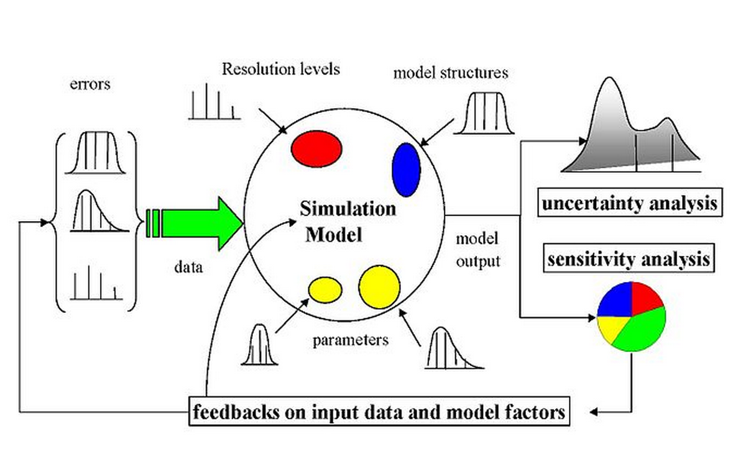

Figure 1 The scheme of a sampling-based sensitivity analysis. Uncertainty would arise from different sources—errors in the data, parameter estimation procedure, and alternative model structures—they are propagated through the model for uncertainty analysis and their relative importance is quantified via sensitivity analysis.



Figure 2 Three different exposure intake routes of the pollen.



Figure 3 Schematic diagram of modeling exposure to pollen in 9 climate regions. Concentrations and surface loading of pollen were simulated based on observed daily pollen counts from AAAAI monitoring stations. Exposures to pollens were simulated based on the concentration profiles and activity data of different groups by ages and sex from United States Census Bureau. The intake dose calculated from exposure modeling is then used as input to conduct sensitivity analysis.

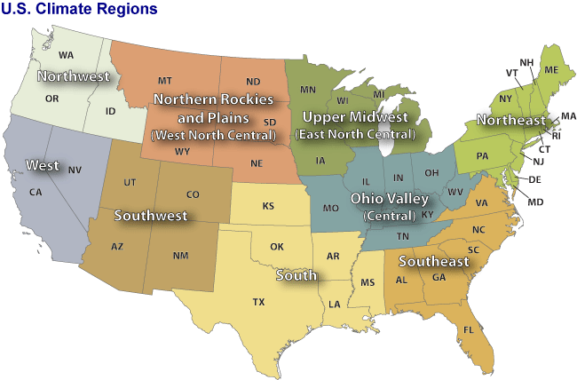

Figure 4 Nine climate regions in the contiguous United States. Through climate analysis, National Climatic Data Center scientists have identified nine climatically consistent regions within the contiguous United States which are useful for putting current climate anomalies into a historical perspective(Karl and Koss 1984)

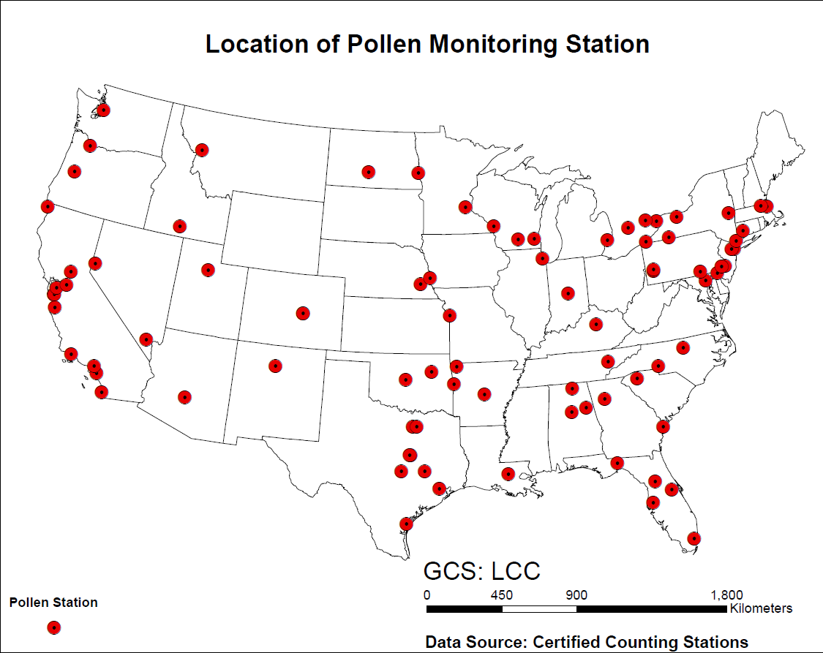

Figure 5 Locations of the American Academy of Allergy Asthma and Immunology (AAAAI) monitor stations for airborne pollen in the United States. Pollen counts data were obtained from these monitor stations in each climate regions.



Figure 6 Inhalation rate by weight of male and female, respectively. The data are from EFH handbook (U.S. Environmental Protection Agency 2010). There are 14 age groups from the original data resources, for each gender. The age groups are 0-1 year, 1-2 years, 2-3 years, 3-6 years, 6-11 years, 11-16 years, 16-21 years, 21-31 years, 31-41 years, 41-51 years, 51-61 years, 61-71 years, and 71-81 years. The percentiles are from 5th to 95th. (5th, 10th, 25th, 50th, 75th, 90th, 95th)



Figure 7 Inhalation rate of male and female, respectively. The data are from EFH handbook (U.S. Environmental Protection Agency 2010). There are 14 age groups from the original data resources, for each gender. The age groups are 0-1 year, 1-2 years, 2-3 years, 3-6 years, 6-11 years, 11-16 years, 16-21 years, 21-31 years, 31-41 years, 41-51 years, 51-61 years, 61-71 years, and 71-81 years. The percentiles are from 5th to 95th. (5th, 10th, 25th, 50th, 75th, 90th, 95th)



Figure 8 Surface area of human body. The data are from EFH handbook (U.S. Environmental Protection Agency 2010). There are 17 age groups from the original data resources, for each gender. The age groups are 1-3 months, 3-6 months, 6-12 months, 1-2 years, 2-3 years, 3-6 years, 6-11 years, 11-16 years, 16-21 years, 21-31 years, 31-41 years, 41-51 years, 51-61 years, 61-71 years, and 71-81 years.81 years and older. The percentiles are from 5th to 95th. (5th, 10th, 25th, 50th, 75th, 90th, 95th)





Figure 9 Time series of observed daily pollen concentration of Ambrosia at Cherry Hill (top) and Newark (Bottom) monitor stations which locate in the Northeast Climate Zones. The pollen data are from National Allergy Bureau(National Allergy Bureau 2010).





Figure 10 Time series of observed daily pollen concentration of Artemisia in Cherry Hill (top) and Newark (Bottom) monitor stations which locate in the Northeast Climate Zones. The pollen data are from National Allergy Bureau(National Allergy Bureau 2010)





Figure 11 Time series of observed daily pollen concentration of Betula in Cherry Hill (top) and Newark (Bottom) monitor stations which locate in the Northeast. The pollen data are from National Allergy Bureau(National Allergy Bureau 2010).





Figure 12 Time series of observed daily pollen concentration of Gramineae in Cherry Hill (top) and Newark (Bottom) monitor station which locate in the Northeast. The pollen data are from National Allergy Bureau(National Allergy Bureau 2010).



Figure 13 Time series of observed daily pollen concentration of pollen concentration of Ambrosia in Cherry Hill (top) and Newark (Bottom) monitor stations which locate in the Northeast. The pollen data are from National Allergy Bureau(National Allergy Bureau 2010)

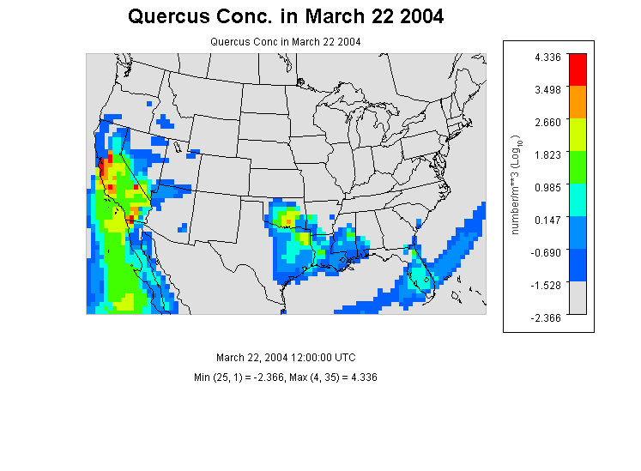

Figure 14 Quercus Concentration in the contiguous U.S. at 12:00 (UTC) in March 22 in 2004. Low concentrations of pollen are observed only in the southwest coast, which is in the southwest climate region. No obvious observation of pollen are reported in other climate region.



Figure 15 The observed cumulative probability distributions of daily pollen concentration for Ambrosia in the 9 nine climates regions.



Figure 16 The observed cumulative probability distributions of daily pollen concentration for Artemisia in the 9 climates regions. The concentration profile in southwest is slightly smooth than in other climate regions.



Figure 17 The observed cumulative probability distributions of daily pollen concentration for Betula in the 9 nine climates regions.



Figure 18 The observed cumulative probability distributions of daily pollen concentration for Gramineae in the 9 nine climates regions.



Figure 19 t The observed cumulative probability distributions of daily pollen concentration for Quercus in the 9 nine climates regions.



Figure 20 Simulated cumulative probability distribution of daily exposure to Ambrosia pollen in different climate zones. Data were from simulation results of 5000 virtual residents in each climate zones under three different exposure routes.



Figure 21 Simulated cumulative probability distribution of daily exposure to Artemisia pollen in different climate zones. Data were from simulation results of 5000 virtual residents in each climate zones under three different exposure routes.



Figure 22 Simulated cumulative probability distribution of daily exposure to Betula pollen in different climate zones. Data were from simulation results of 5000 virtual residents in each climate zones under three different exposure routes.



Figure 23 Simulated cumulative probability distribution of daily exposure to Gramineae pollen in different climate zones. Data were from simulation results of 5000 virtual residents in each climate zones under three different exposure routes.



Figure 24 Simulated cumulative probability distribution of daily exposure to Quercus pollen in different climate zones. Data were from simulation results of 5000 virtual residents in each climate zones under three different exposure routes.



Figure 25 Mean and Standard Deviation of Normalized Sensitivity Coefficient (NSC) for population exposure in Central Climate Region(Ohio Valley)(A) Inhalation (B)Dermal (C) Ingestion (D)Total Exposures The vertical dashed lines represent the NSC values of 0. Number in the figure are parameter IDs:1 u*, 2 k, 3 Dp, 4 Pp, 5 mu, 6λ, 7 Pa, 8 T, 9 Ve, 10 Tind, 11 Tout, 12 F, 13 Sa, 14 Sr, 15 Inf, 16 Inm, 17 Vd, 18 Lr.



Figure 26 Mean and Standard Deviation of Normalized Sensitivity Coefficient (NSC) for population exposure in Southeast Climate Region (A) Inhalation (B)Dermal (C) Ingestion (D)Total Exposures The vertical dashed lines represent the NSC values OF 0. Number in the figure are parameter IDs:1 u*, 2 k, 3 Dp, 4 Pp, 5 mu, 6λ, 7 Pa, 8 T, 9 Ve, 10 Tind, 11 Tout, 12 F, 13 Sa, 14 Sr, 15 Inf, 16 Inm, 17 Vd, 18 Lr,

# Table

Table Coordinates, elevation, main climate characteristics of the studied AAAAI pollen monitoring stations.

|  |  |  |  |  |  |
| --- | --- | --- | --- | --- | --- |
| **Station Name** | **Lat (N)** | **Lon (W)** | **Elevation** | **Climate Region** | **Mean Temp** |
| Corpus Christi, TX | 27.8 | 97.4 | 2 | South | 22.21 |
| Tampa, FL | 28.06 | 82.43 | 12 | Southeast | 22.73 |
| Tallahassee, FL | 30.44 | 84.28 | 62 | Southeast | 19.67 |
| Georgetown, TX | 30.64 | 96.31 | 91 | South | 19.48 |
| College Station, TX | 30.64 | 97.76 | 269 | South | 20.31 |
| Waco, TX | 31.51 | 97.2 | 185 | South | 19.44 |
| Dallas, TX | 33.04 | 96.83 | 207 | South | 19.29 |
| Scottsdale, AZ | 33.49 | 111.92 | 377 | Southwest | 23.98 |
| Orange, CA | 33.78 | 117.86 | 53 | West | 17.93 |
| Atlanta, GA | 33.97 | 84.55 | 366 | Southeast | 16.83 |
| Santa Barbara, CA | 34.44 | 119.76 | 57 | West | 14.86 |
| Huntsville, AL | 34.73 | 86.59 | 191 | Southeast | 16.26 |
| Little Rock, AR | 34.75 | 92.39 | 115 | South | 17.28 |
| Charlotte, NC | 35.3 | 80.75 | 229 | Southeast | 16.02 |
| Fort Smith, AR | 35.35 | 94.39 | 186 | South | 16.49 |
| Oklahoma City, OK | 35.61 | 97.6 | 340 | South | 15.90 |
| Los Alamos, NM | 35.88 | 106.32 | 2227 | Southwest | 11.80 |
| Knoxville, TN | 35.95 | 84.01 | 305 | Central | 15.01 |
| Tulsa 1, OK | 36.03 | 95.87 | 207 | South | 16.17 |
| Durham, NC | 36.05 | 78.9 | 110 | Southeast | 15.71 |
| Las Vegas, NV | 36.17 | 115.15 | 620 | West | 20.93 |
| San Jose 2, CA | 37.31 | 121.97 | 47 | West | 15.69 |
| San Jose 2, CA | 37.33 | 121.94 | 35 | West | 15.69 |
| Pleasanton, CA | 37.69 | 121.91 | 100 | West | 14.18 |
| Lexington, KY | 38.04 | 84.5 | 299 | Central | 13.11 |
| Roseville, CA | 38.76 | 121.27 | 57 | West | 16.96 |
| Colorado Springs 2, CO | 38.87 | 104.82 | 1867 | Southwest | 9.75 |
| Colorado Springs 1, CO | 38.87 | 104.83 | 1868 | Southwest | 9.64 |
| Kansas City, MO | 39.08 | 94.58 | 288 | Central | 13.91 |
| Baltimore, MD | 39.37 | 76.47 | 36 | Northeast | 13.33 |
| Reno, NV | 39.56 | 119.77 | 1382 | West | 12.08 |
| New Castle, DE | 39.66 | 75.57 | 3 | Northeast | 13.46 |
| Indianapolis, IN | 39.91 | 86.2 | 254 | Central | 11.98 |
| York, PA | 39.94 | 74.91 | 13 | Northeast | 12.72 |
| Cherry Hill, NJ | 39.94 | 76.71 | 195 | Northeast | 13.04 |
| Philadelphia, PA | 39.96 | 75.16 | 12 | Northeast | 13.46 |
| Pittsburgh, PA | 40.47 | 79.95 | 287 | Northeast | 11.20 |
| Newark, NJ | 40.74 | 74.19 | 43 | Northeast | 13.02 |
| Lincoln, NE | 40.82 | 96.64 | 371 | West North Central | 11.03 |
| Armonk, NY | 41.13 | 73.73 | 187 | Northeast | 11.09 |
| Omaha, NE | 41.14 | 95.97 | 305 | West North Central | 10.95 |
| Waterbury, CT | 41.55 | 73.07 | 140 | Northeast | 11.83 |
| Chicago, IL | 41.91 | 87.77 | 189 | Central | 11.03 |
| Olean, NY | 42.09 | 78.43 | 433 | Northeast | 7.30 |
| Erie, PA | 42.1 | 80.13 | 215 | Northeast | 10.12 |
| Salem, MA | 42.5 | 70.92 | 42 | Northeast | 10.90 |
| St. Clair Shores, MI | 42.51 | 82.9 | 180 | East North Central | 9.82 |
| Twin Falls, ID | 42.58 | 114.46 | 1124 | Northwest | 10.23 |
| Chelmsford, MA | 42.6 | 71.35 | 37 | Northeast | 10.01 |
| Albany, NY | 42.68 | 73.77 | 72 | Northeast | 9.41 |
| London, ON, Canada | 42.99 | 81.25 | 250 | Central | 8.34 |
| Waukesha, WI | 43.02 | 88.24 | 270 | East North Central | 9.60 |
| Madison, WI | 43.08 | 89.43 | 263 | East North Central | 8.66 |
| Niagara Falls, ON , Canada | 43.09 | 79.09 | 188 | Northeast | 9.27 |
| Rochester, NY | 43.1 | 77.58 | 148 | Northeast | 9.33 |
| LaCrosse, WI | 43.88 | 91.19 | 216 | East North Central | 8.96 |
| Eugene, OR | 44.04 | 123.09 | 129 | Northwest | 11.35 |
| Vancouver, WA | 45.62 | 122.5 | 89 | Northwest | 12.25 |
| Fargo, ND | 46.84 | 96.87 | 277 | West North Central | 5.89 |
| Seattle, WA | 47.66 | 122.29 | 20 | Northwest | 11.94 |

Table 2 Parameters for calculating population exposure to pollen in 9 different climate regions in United States. These parameters were listed either as fixed values, known distributions or unknown empirical distribution derived from the literatures.

|  |  |  |  |  |  |
| --- | --- | --- | --- | --- | --- |
|  | **Parameter** | **ID** | **Distribution** | **Mean(STD)** | **Range** |
| u* | friction velocity(m/s) | 1 | fixed | 1.17 | - |
| k | von karman constant(dimensionless) | 2 | fixed | 0.41 | - |
| Dp | diameter of pollen(m) | 3 | fixed | 2.00E-05 | - |
| Pp | density of pollen(kg/m3) | 4 | fixed | 840 | - |
| mu | viscosity of air (m/s) | 5 | fixed | 1.81E-05 | - |
| λ | mean free path of air molecules(m) | 6 | fixed | 6.80E-08 | - |
| Pa | density of air(kg/m3) | 7 | fixed | 1.145 | - |
| T | temperature(k) | 8 | range | 298 | 283-310 |
| Ve | ventilation rate(dimensionless) | 9 | range | 1.2 | 0.5-2 |
| Tind | indoor time(min) | 10 | norm | 1279(21) | - |
| Tout | outdoor time(min) | 11 | norm | 174(4) | - |
| Fr | hand contact with mouth frequency | 12 | empirical | 30 | 3-65 |
| Sa | human surface area(m2) | 13 | lognorm | 1.76 | 0.41-2.51 |
| Sr | hand surface area ratio(%) | 14 | lognorm | 5.3 | 4.8-5.6 |
| Ihf | female inhalation rate (m3/day) | 15 | uniform | 1.33 | 0.19-1.91 |
| Ihm | male inhalation rate(m3/day) | 16 | uniform | 1.45 | 0.20-1.50 |
| Vd | indoor ventilation rate(dimensionless) | 17 | empirical | 1.75 | - |
| Lr | Efficiency of adherence to skin (dimensionless) | 18 | empirical | 0.0001 |  |
|  |  |  |  |  |  |

Table 3 Median and Range of the Total Exposure Values in 9 Climate Regions ( Pollen / Day )

|  |  |  |  |  |  |  |
| --- | --- | --- | --- | --- | --- | --- |
| **Species** | **Percentile** | **Central** | **EastNorthCentral** | **NorthEast** | **NorthWest** | **South** |
| birch (Betula) | 25% | 9 | 7 | 12 | 14 | 11 |
|  | 50% (Median) | 14 | 13 | 26 | 45 | 21 |
|  | 75% | 30 | 28 | 77 | 176 | 53 |
|  | 95% | 120 | 79 | 362 | 645 | 167 |
| ragweed (Ambrosia) | 25% | 17 | 23 | 39 | 14 | 13 |
|  | 50% (Median) | 47 | 82 | 74 | 35 | 37 |
|  | 75% | 139 | 264 | 279 | 160 | 159 |
|  | 95% | 739 | 1176 | 2553 | 1325 | 1272 |
| mugwort (Artemisia) | 25% | 37 | 26 | 17 | 7 | 35 |
|  | 50% (Median) | 90 | 118 | 50 | 15 | 150 |
|  | 75% | 359 | 444 | 145 | 25 | 684 |
|  | 95% | 2191 | 1246 | 641 | 53 | 3264 |
| grass (Gramineae) | 25% | 13 | 10 | 14 | 15 | 16 |
|  | 50% (Median) | 33 | 23 | 28 | 48 | 41 |
|  | 75% | 100 | 61 | 72 | 179 | 128 |
|  | 95% | 534 | 235 | 296 | 1520 | 4026 |
| oak (Quercus) | 25% | 31 | 42 | 57 | 14 | 76 |
|  | 50% (Median) | 100 | 172 | 129 | 48 | 433 |
|  | 75% | 380 | 716 | 682 | 184 | 1693 |
|  | 95% | 2740 | 2049 | 5250 | 733 | 6044 |
| **Species** | **Percentile** | **SouthEast** | **SouthWest** | **West** | **WestNorthCentral** | **US** |
| birch (Betula) | 25% | 8 | 10 | 10 | 8 | 10 |
|  | 50% (Median) | 18 | 25 | 20 | 17 | 22 |
|  | 75% | 48 | 220 | 49 | 40 | 80 |
|  | 95% | 125 | 1517 | 172 | 139 | 370 |
| ragweed (Ambrosia) | 25% | 17 | 5 | 13 | 15 | 17 |
|  | 50% (Median) | 51 | 7 | 33 | 48 | 46 |
|  | 75% | 185 | 10 | 114 | 167 | 164 |
|  | 95% | 901 | 57 | 703 | 936 | 1074 |
| mugwort (Artemisia) | 25% | 13 | 10 | 9 | 18 | 64 |
|  | 50% (Median) | 38 | 22 | 17 | 76 | 64 |
|  | 75% | 122 | 94 | 48 | 336 | 251 |
|  | 95% | 531 | 1092 | 297 | 1554 | 1208 |
| grass (Gramineae) | 25% | 11 | 10 | 109 | 10.8.3 | 25 |
|  | 50% (Median) | 21 | 22 | 141 | 23 | 42 |
|  | 75% | 50 | 49 | 189 | 64 | 99 |
|  | 95% | 182 | 222 | 314 | 267 | 844 |
| oak (Quercus) | 25% | 43 | 10 | 26 | 27 | 36 |
|  | 50% (Median) | 211 | 24 | 79 | 93 | 143 |
|  | 75% | 1440 | 98 | 237 | 383 | 646 |
|  | 95% | 8564 | 724 | 1330 | 2714 | 3350 |

Table 4 Mean and Standard Deviation of the Total Exposure Values in 9 Climate Regions ( Pollen / Day )

|  |  |  |  |  |  |
| --- | --- | --- | --- | --- | --- |
| **Species** | **Central** | **EastNorthCentral** | **NorthEast** | **NorthWest** | **South** |
| birch (Betula) | 42 (150.36) | 23 (28.47) | 91 (236.71) | 152 (245.53) | 47 (72.32) |
| ragweed (Ambrosia) | 200(799.64) | 273 (587.47) | 658 (3173.24) | 305 (1064.32) | 293 (1007.41) |
| mugwort (Artemisia) | 527(1754.62) | 329(517 66) | 151 (307.35) | 19 (18.64) | 702 (1419.49) |
| grass (Gramineae) | 139 (431.03) | 59.63 (108.70) | 82 (211.49) | 317 (1301.71) | 250 (680.03) |
| oak (Quercus) | 649 (2451.03) | 787 (1654.32) | 1277 (7453.23) | 173 (341.94) | 1593 (5033.45) |
| **Species** | **SouthEast** | **SouthWest** | **West** | **WestNorthCentral** | **US** |
| birch (Betula) | 36 (48.50) | 313 (821.64) | 51 (115.48) | 37 (60.90) | 88 (317.63) |
| ragweed (Ambrosia) | 244 (901.04) | 13 (24.87) | 158 (437.95) | 224 (793.14) | 263 (1293.42) |
| mugwort (Artemisia) | 124 (263.33) | 227 (781.93) | 105 (497.33) | 369 (984.45) | 284 (927.63) |
| grass (Gramineae) | 51 (110.57) | 57 (128.50) | 7374 (12159.43) | 69 (169.47) | 933 (4065.78) |
| oak (Quercus) | 1856 (4998.85) | 159 (430.62) | 347 (1145.58) | 604 (2294.38) | 822 (3171.56) |

Table 5 Median of the Exposure in Central Climate Region through Different Exposure Routes ( Pollen / Day )

|  |  |  |  |  |  |
| --- | --- | --- | --- | --- | --- |
| **Species** | **Median or Mean** | **Inhalation** | **Dermal Contact** | **Ingestion** | **Total** |
| birch (Betula) | Median | 22.00 | 0.04 | 0.09 | 22.00 |
|  | Mean | 88.00 | 0.00 | 0.00 | 89.00 |
| ragweed (Ambrosia) | Median | 46.00 | 0.12 | 0.27 | 47.00 |
|  | Mean | 263.00 | 0.00 | 1.00 | 264.00 |
| mugwort (Artemisia) | Median | 64.00 | 0.23 | 0.00 | 65.00 |
|  | Mean | 284.00 | 0.00 | 1.00 | 285.00 |
| grass (Gramineae) | Median | 42.00 | 0.09 | 0.19 | 43.00 |
|  | Mean | 933.00 | 1.00 | 1.00 | 936.00 |
| oak (Quercus) | Median | 143.00 | 0.26 | 0.59 | 144.00 |
|  | Mean | 822.00 | 1.00 | 1.00 | 824.00 |

Table 6 Mean Time Spent at 3 Locations for Both CARB and National Studies (Robinson and Thomas 1991, U.S. Environmental Protection Agency 2010)

|  |  |  |  |  |
| --- | --- | --- | --- | --- |
| **Mean Duration(Minutes/Day)** | | | | |
| **Location Category** | **CARB** | **SE** | **National** | **SE** |
| Indoor | 1279.0 | 21.0 | 1279.0 | 21.0 |
| outdoor | 74 | 4 | 74 | 4 |
| In-vehicle | 87.0 | 2.0 | 87.0 | 2.0 |

SE = Standard error of mean.

CARB=California Air Resources Board

Difference between the mean values for the CARB and national studies is not statistically significant.

Difference between the mean values for the CARB and national studies is statistically significant at the 0.05 level.

Reference

Bateman, E., S. Hurd, P. Barnes, J. Bousquet, J. Drazen, M. FitzGerald, P. Gibson, K. Ohta, P. O'byrne and S. Pedersen (2008). "Global strategy for asthma management and prevention: GINA executive summary." European Respiratory Journal **31**(1): 143-178.

Behrendt, H. and W.-M. Becker (2001). "Localization, release and bioavailability of pollen allergens: the influence of environmental factors." Current Opinion in Immunology **13**(6): 709-715.

Bielory, L., K. Lyons and R. Goldberg (2012). "Climate change and allergic disease." Current allergy and asthma reports **12**(6): 485-494.

Brożek, J. L., J. Bousquet, C. E. Baena-Cagnani, S. Bonini, G. W. Canonica, T. B. Casale, R. G. van Wijk, K. Ohta, T. Zuberbier and H. J. Schünemann (2010). "Allergic Rhinitis and its Impact on Asthma (ARIA) guidelines: 2010 revision." Journal of Allergy and Clinical Immunology **126**(3): 466-476.

Census Bureau. U.S (2010). "Profile of General Population and Housing Characteristics: 2010 ".

Chuine, I., J. Belmonte and A. Mignot (2000). "A modelling analysis of the genetic variation of phenology between tree populations." Journal of Ecology **88**(4): 561-570.

Cohen, S. H., J. W. Yunginger, N. Rosenberg and J. N. Fink (1979). "Acute allergic reaction after composite pollen ingestion." Journal of Allergy and Clinical Immunology **64**(4): 270-274.

Eder, W., M. J. Ege and E. von Mutius (2006). "The asthma epidemic." New England Journal of Medicine **355**(21): 2226-2235.

Fogh, C. L. and K. G. Andersson (2000). "Modelling of skin exposure from distributed sources." Annals of Occupational Hygiene **44**(7): 529-532.

Gould, H. J., B. J. Sutton, A. J. Beavil, R. L. Beavil, N. McCloskey, H. A. Coker, D. Fear and L. Smurthwaite (2003). "The biology of IgE and the basis of allergic disease." Annual review of immunology **21**(1): 579-628.

Hu, X., Y. Zhang, J. Luo, T. Wang, H. Lian and Z. Ding (2011). "Bioaccessibility and health risk of arsenic, mercury and other metals in urban street dusts from a mega-city, Nanjing, China." Environmental Pollution **159**(5): 1215-1221.

Karl, T. and W. J. Koss (1984). Regional and National Monthly, Seasonal, and Annual Temperature Weighted by Area, 1895-1983, National Climatic Data Center.

Lamb, C. E., P. H. Ratner, C. E. Johnson, A. J. Ambegaonkar, A. V. Joshi, D. Day, N. Sampson and B. Eng (2006). "Economic impact of workplace productivity losses due to allergic rhinitis compared with select medical conditions in the United States from an employer perspective." Current Medical Research and Opinion® **22**(6): 1203-1210.

National Allergy Bureau (2010). NAB Pollen Counts.

Passalacqua, G. and S. R. Durham (2007). "Allergic rhinitis and its impact on asthma update: allergen immunotherapy." Journal of allergy and clinical immunology **119**(4): 881-891.

Robinson, J. P. and J. Thomas (1991). Time spent in activities, locations, and microenvironments: A California-national comparison. Project report, General Sciences Corp., Laurel, MD (United States).

Shea, K. M., R. T. Truckner, R. W. Weber and D. B. Peden (2008). "Climate change and allergic disease." Journal of allergy and clinical immunology **122**(3): 443-453.

Singh, K., S. Axelrod and L. Bielory (2010). "The epidemiology of ocular and nasal allergy in the United States, 1988-1994." Journal of Allergy and Clinical Immunology **126**(4): 778-783. e776.

Sofiev, M., J. Belmonte, R. Gehrig, R. Izquierdo, M. Smith, Å. Dahl and P. Siljamo (2013). Airborne Pollen Transport. Allergenic Pollen, Springer**:** 127-159.

U.S. Environmental Protection Agency (2010). Exposure factors handbook, EPA Washington, DC.

Zhang, Y., S. Isukapalli, P. Georgopoulos and C. Weisel (2013). "Modeling Flight Attendants’ Exposures to Pesticide in Disinsected Aircraft Cabins." Environmental Science & Technology.